STRATEGIC PLAN

2013-2015

**CUPE LOCAL 960 STRATEGIC PLAN**

***THE LIBRARY WORKS BECAUSE WE DO***

For CUPE LOCAL 960

**[](http://www.cupe960.org/)**

[**www.cupe960.org**](http://www.cupe960.org)

**Twitter: @cupe960**

**Facebook: www.facebook.com/cupelocal960**

**Submitted by:**

Tiffany Balducci

CUPE Local 960 Interim President

**April 10, 2013**

**Revised September 12, 2013**

Table of Contents

Document Objective 4

OUR VISION 4

short term goals 6

Value Proposition 8

Long Term Goals 10

Communications Wheel 11

Action Plan 11

Required Resources 15

Document Objective

The purpose of this plan is to document information and to set goals for our Local. It will help determine what will be implemented over a matter of weeks and years allowing our Local to grow and evolve and ultimately serve our membership better. In summary:

* Where are we now?
* Where do we want to be?
* How do we get there?

Our Vision

Mission Statement

To enrich the lives of our members and working people everywhere.

Vision

As recognized leaders within the Labour Movement, Local 960 will:

* Cultivate a culture of solidarity
* Demand security, dignity, and respect for our members
* Mobilize our membership, and
* Impact public policy that effects social and economic change to benefit working people

Objectives and Initiatives

To foster honesty and trust in the understanding that we are here to work together for the common good of YOU - our membership. To improve communications and professionalism between our membership and management that will foster and maintain continual improvements in our working environment and opportunities. To promote fairness and integrity in how management treats our members in all aspects of employment at the Oshawa Public Libraries. To be the collective voice of our members in representing them in conflicts with management and in policy changes. Strength in our membership only empowers us to have a larger role in our own destinies.

CUPE Local 960 Organization Structure

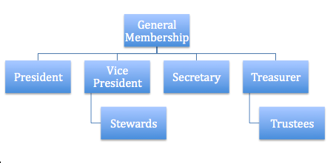

**General Membership Meetings (GMMs)** are the ultimate plenary authority in CUPE 960. Our Bylaws require regular meetings shall be held monthly (except July, August and December) at a time and place to be decided by the Executive Board each year, subject to membership approval. At least seven (7) days notice shall be given.

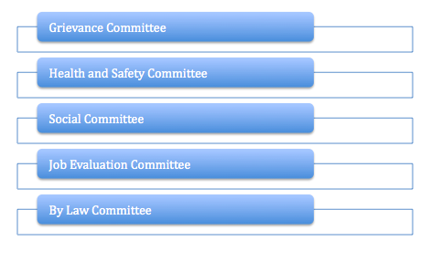

Executive Board Contact List

|  |  |  |  |
| --- | --- | --- | --- |
| **Name** | **Title** | **Telephone Number** | **E-mail Address** |
| **Tiffany Balducci** | **President** |  | **tiffanycupe960@gmail.com** |
| **Rick Johnston** | **Vice President** |  | **960rick@gmail.com** |
| **Katy Brennan** | **Secretary** |  | **secretarycupe960@gmail.com** |
| **Laura McEwan** | **Treasurer** |  | **lauracupe960@gmail.com** |

Current Status

* Expanded Steward network
* Local has a structure to communicate with and mobilize members one-on-one
* Local regularly distributes information
* Members can contact the Local 24/7 through emails or voice mail
* Local conducts new member orientations
* Local encourages diversity of leaders / activists in order to be representative of the membership
* Education is extremely valued
* Excellent Social Committee and engagement

Short Term Goals

Local 960 decided their short-term goals and priorities would be:

* Revamp by-laws using the suggested template from CUPE National
* Collect all members personal emails
* Pressure management to create a joint sustainability in the workplace committee
* Send members to as many education/school possibilities as feasible
* Create a job posting binder
* Organize retirees
* Create coalitions in the community
* Communicate in new and effective ways
* Constantly maintain the Equality Statement
* Get all of our members membership cards
* Create budget for rest of 2013/2014 for schools, attending conferences, etc.
* Increased presence in the local community

|  |  |  |
| --- | --- | --- |
| **Action** | **Person Responsible** | **Time Frame** |
| Revamp By-Laws | By-Law Committee | Due: early May 2013 |
| Collect all members personal emails | Recording Secretary | Due: May 2013 |
| Joint sustainability in the workplace committee | Executive Board | June 2013 |
| Create Job Posting Binder | Recording Secretary | Due: May 2013 |
| Organize retirees | Vice President | Due: 2014 |
| Create coalitions in the community | Executive Board | Ongoing |
| Get all of our members membership cards | Executive Board | September 2014 |
| Create budget for 2014 | Treasurer | January 2014 |
| Create Strategic Plan |  | Due: September 2014 |

Value Proposition

**SOLIDARITY CREATES OPPORTUNITIES**

***The individual can act on their own, but together, we can do more***

The trade union movement is a community for wage earners. Our goal is to give the individual the opportunity for and the freedom to act on his or her own – and the foundation for this is created through solidarity and community.

Through collective agreements, the trade union movement secures the rights of the individual worker as well as ensuring workers’ job security with a view to give everyone the possibility to develop their abilities.

The individual should have the opportunity to take responsibility for his or her own situation and to take joint responsibility for the community.

The preconditions for freedom are jobs for everyone, economic justice and equal access to social assets. The trade union movement will work to ensure these goods remain on a sustainable foundation.

We want a society built on democracy, safety, social justice, a clean environment and development opportunities for the individual. Through collective agreements and political regulation of the economy, we would like to see the continuous development of a just society and we shall work to ensure that this development takes place on an environmentally sound and socially sustainable basis.

Our community shall also include marginalized groups who are not members and who have difficulties gaining a foothold on the labour market and in society. We are under a particular obligation to break the negative social heritage of these groups.

The trade union movement has a global responsibility. Solidarity includes workers in all parts of the world and we shall contribute to ensuring political, social and economic rights for all.

**All human beings have equal value**

All humans are different but they all have equal value, thus deserve equal rights and opportunities. No one should be discriminated against, neither directly nor indirectly, on the basis of gender, age, disabilities/special needs, race, skin colour, religion, political views, sexual orientation or national, social or ethnic origins.

Opportunities

With the 2014 Municipal Elections in the near future, we are in an ideal position to work with our politicians to achieve our goals; how to talk about enhancing public services and jobs; and how to hold our municipal politicians accountable. No other sector has as good an opportunity to meet with and elect the people who have a direct impact on our members’ job security and the services they provide. We can learn how to identify allies strengthen existing ties, develop relationships and build coalitions that will support our political and bargaining strategies that will move us forward.

Long Term Goals

Local 960 decided their long-term goals and priorities would be:

* Improve member engagement and mobilization
* Improve communications
* Create and strengthen coalitions/Promote Activism
* Continually strengthen our collective agreement through strong effective bargaining

Long Term Plan

**Improve member engagement and mobilization:**

* Improve attendance and participation at general membership meetings
* Continue to meet with new members face-to-face, hand out welcome packages
* Create new committees: Young Workers’ Committee, Retirees, Communication, Committee Against Racism and Discrimination, Womens’ Committee, Pink Triangle
* Lunch and Learn sessions in the workplace
* Continue to hold excellent social events
* Promote education
* Focus on member-to-member grassroots communication

**Improve communications:**

* Maintain the Local’s website and social media
* Collect members’ home emails thus becoming less reliant on employers’ email system
* Celebrate our success instead of focusing on the fight
* Create a campaign that is dynamic and youthful
* Brand our local so the community supports us
* Lead by example
* Self-promote members and successes
* Develop positive image with community involvement
* Use bulletin board and make it more appealing
* Distribute promotional materials/set up suggestion boxes

.

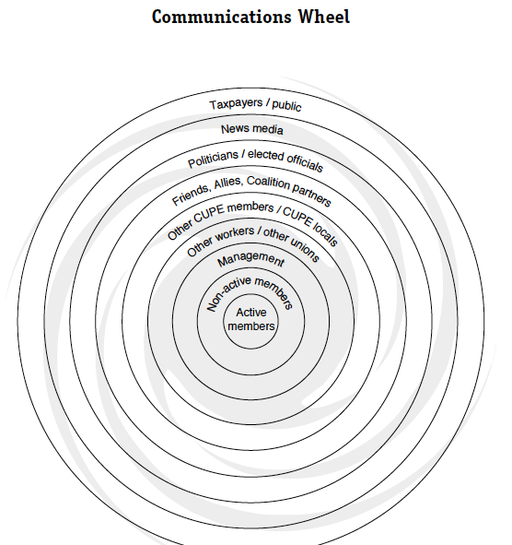

**Create and Strengthen Coalitions/Improve Activism:**

* Attend Library Board meetings
* Attend Area 5 and Durham/Northumberland CUPE Council Meetings
* Create a CUPE Kids Club to foster young activism, involve children so more members can be involved
* Identify and meet with community partners and city councilors
* Mobilize our members to contact their councilors and MPP
* Create a CUPE Action Team (CAT) that can work with other locals to support strikes, campaigns, and more
* Affiliate with Labour Organizations

**Continually strengthen our collective agreement through strong effective bargaining:**

* Public campaign to educate the community on the great work our members do
* Rely on CUPE’s research
* Seek disclosure from the employer well in advance of bargaining
* Educate our membership on how bargaining works
* Seek input from the membership on their priorities for bargaining
* Elect/appoint our bargaining committee and provide education

Action Plan

|  |  |  |  |  |
| --- | --- | --- | --- | --- |
| **Vision Subject** | **Date Started** | **Action Required** | **Assigned To** | **Date Due/Completed** |
| **Member Engagement and Mobilization** |  | GMM attendance |  |  |
| GMM Attendance | February 2012 | Identify guest speakers to draw members out | Recording Secretary to collaborate with committees | December, 2013 |
| February 2012 | Rotate location of meetings | Executive Board | Continual |
| Create New Committees | March 2013 | Re-write By-laws to have new committees listed | By-Law Committee | June, 2013 |
| Member-to-Member Mobilization | April 2013 | Meet with every single member of CUPE 960 | Ad-hoc Committee | November, 2014 |
| Create suggestion boxes at all branches |  | Have attractive suggestion boxes at all locations | Recording Secretary to create boxes |  |
| **Improve Communications** |  |  |  |  |
| Collect Member home emails | April 2013 | Develop a strategy to encourage members to provide emails and report back | Recording Secretary and stewards | May 20, 2013 |
| Update website and social media | February 2013 | Get constant feed-back from members | Webmaster | Continual |
| Create a campaign | 2013 | Form communications committee that will focus on rebranding | Executive, communication committee | 2014 |
|  | October 2013 | Rebrand CUPE 960 – new posters and logo | Executive, communications committee | November, 2014 |
| Communications Wheel | May 2013 | Follow and implement communications wheel | Executive and identified committees | December 2014 |
| Create Book Club | September 2013 | Have a CUPE 960 Book Club that focuses on labour movement, anti-discrimination, women’s issues, etc. books for members and public | Any interested members/  Social Committee | Continual |
| **Vision Subject** | **Date Started** | **Action Required** | **Assigned To** | **Date Due/Completed** |
| **Strengthen Collective Agreement/Strong Effective Bargaining** |  |  |  |  |
| Bargaining Committee | October/November 2013 | Hold educational on bargaining – all members welcome | Bargaining Chair | No less than half year prior to bargaining (October 2013) |
| Meet with CUPE National Rep | January/February 2013 | Bargaining Committee to meet with National Rep | Bargaining Committee as of February 2014 | February, 2014 |
| Send out survey to members | January 2014 | Get constant feed-back from members | Bargaining committee | March 2014 |
| **Create and Strengthen Coalitions/Improve Activism** |  |  |  |  |
| Create CUPE Action Team | May 2013 | Show ‘We Are Wisconsin’ have people sign up to be on ‘CAT’ | Executive with locals 129, 905 | May/June 2013 |
| Attend Library Board Meetings | 2013 | Have a member of executive attend every library board meeting | Member of executive or membership | Continual, must report back to membership |
| Attend Area 5 and Durham Northumberland CUPE Council meetings | 2012 | Have as many members involved in these meetings as possible | Elected members, anyone | Continual |
| Create CUPE Kids Club | 2013 | Involving our members kids will allow them to be move involved themselves | Kristin Ouimet, Katy Brennan, any other interested members | Get the club up and running by 2014 |
| Identify coalitions/partnerships | 2013 | Identify possibly partnerships | Executive | Report to membership by November 2013 |
|  | March 2013 | Partnership identified with OPL Management, will work alongside rather than fight | Executive Board, Social Committee | Continual |
|  |  |  |  |  |

Required Resources

Member support

Strategic Plan Ad-hoc Committee

Education

Community Support

Possible budget

